AWS to On-premises Site-to-Site VPN Setup:
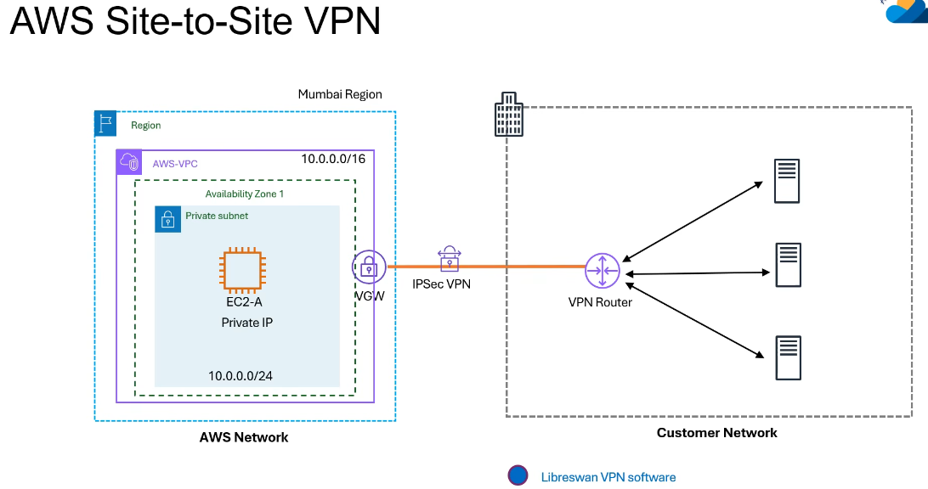
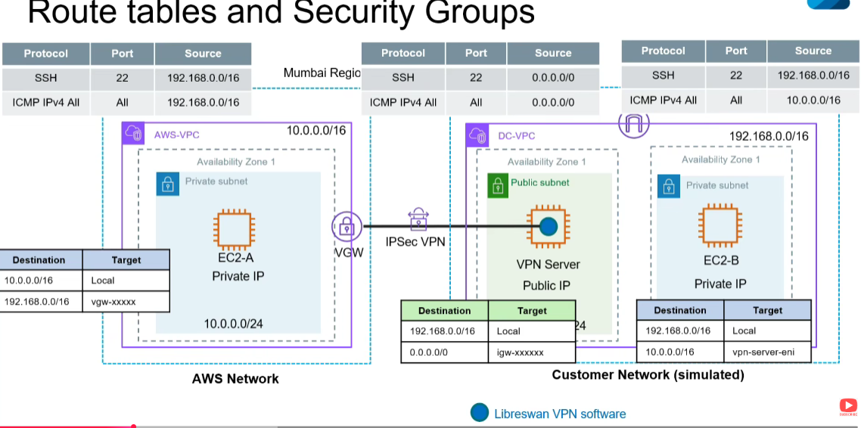

Create VPC on AWS VPC network (10.0.0.0/16) -Mumbai Region:
  - Subnets -> create Subnets
- Select VPC ->AWS VPC
- Subnet Settings:
Subnet name: AWS-Private-subnet
- AZ: aps1-az1
- IPV4 VPC CIDR block: 10.0.0.0/16
- IPV4 subnet CIDR block: 10.0.0.0/24
Click Create subnet

  - Route Table:
Name: AWS-Private RT
VPC: AWS VPC
Click Create route table
  - Subnet Association:
AWS-Private -subnet
Click save association.
EC2 _Mumbai Region:
- EC2-Instance
- Lauch Instance
- Name: EC2-A
- Key pair: Mumbai-Key Pair
- Network Setting ->Edit
VPC: AWS VPC
Subnet: AWS-Private -subnet
Security Group name: AWS-app-sg
Type: All -icmp-ipv4
Source type: Custom Source 192.168.0.0/16 !! DC subnet range!!
Lauch Instance

DC on-premises VPC :(N. Virginia) Region
VPC -> Create VPC
Name: DC VPC; IPV4 CIDR: 192.168.0.0/16 -> Create VPC
We need internet gateway to Shh for private subnet in DC
Click internet gateways
Create Internet gateway -> Name: DC-IGW->Click create IG and Attach to a VPC->DC VPC
Go to Subnet: Create Subnet -> VPC ID: DC VPC
Subnet 1: DC-Public-Subnet -> AZ: us-east-1a->IPV4 subnet CIDR block: 192.168.0.0/24
Subnet 2: DC-Private-Subnet -> AZ: us-east-1a->IPV4 subnet CIDR block: 192.168.100.0/24
Click Create Subnets. Create the Route Table for these subnets.

Route Table -> name: DC-Public-RT -> VPC: DC-VPC ->click create route table. Since its public we need to create route for the IGW
Edit Route->0.0.0.0/0 Target will be Internet gateway name: DC-IGW and need to Associate with public subnet.
Select the subnet association->select DC-Public-Subnet ->Save associations.

Route table for Private subnets:
Name: DC-Private-RT ->VPC: DC-VPC->Click Create route table. Associate with private subnet.
Subnet association -> Edit subnet associations ->Select DC-Private-Subnet

EC2 on DC side N. Virginia region:
Name: VPN Server -> key pair: Virgina ->Network Settings ->VPC: DC-VPC
Subnet: DC-Public-Subnet ->Auto-assign Public IP: Enable
Create Security Group->name: vpn-server-sg: All ICMP-IPV4 ->Anywhere ->Launch instance
Name: EC2-B -> key pair: Virgina ->Network Settings ->VPC: DC-VPC
Subnet: DC-Private-Subnet
Create Security Group->name: ec2-b-sg;
SSH; Source type: Custom and Source :192.168.0.0/16 and Type: All ICMP-IPv4; Source type: Custom and Source: 10.0.0.0/16 Launch instance

Going to Create IP Sec VPN:
1.Create Virtual private gateway:
AWS Mumbai Region -> VPC -> Virtual private Network (VPN) -> Virtual private gateways
Click -> Create Virtual private gateways ->Name: aws-network-vpg
Action ->Attach to a VPC -> AWS-VPC
2. Create the customer gateway:
Create Customer gateway ->name: dc-network-cgw
ASN: 65000 (default)-> IP address: 100.54.103.186 (!! DC public IP of VPN Server EC2!!) -Click create customer gateway
3.Create the VPN Connection:
Site-to-Site VPN Connection->Create VPN Connection->name: aws-dc-vpn
Target type: Virtual Private Gateway ->Select aws-network-vpg
Customer gateway ID: dc-network-cgw
Routing option: Static
Static IP prefix: 192.168.0.0/16
Click create VPN Connection

Once VPN Connection is created on AWS side and need to download the Configuration. Click Download Configuration. Vendor: Openswan reaming leave it as it is and click download and save as text file.

Login to DC Side Public EC2 instance using SSH:
Amazon Linux 2023 AMI:
Install Libreswan on VPN server:
$sudo yum install libreswan -y
Make it root user:
sudo vi /etc/sysct1.conf
1.Copy the details from the VPN connection download configuration:
net.ipv4.ip_forward = 1
net.ipv4.conf.default.rp_filter = 0
net.ipv4.conf.default.accept_source_route = 0
save the file
2.$ Sudo sysctl -p -> to apply the changes
3.Go to VPN connection download configuration to0 check the content for the config /etc/ipsec.conf
$ Cat /etc/ipsec.conf – at he last “# “ should not be included
4.Create New file at /etc/ipsec.d/aes.conf
5. $ sudo vi /etc/ipsec.d/aws.conf -> copy the conn Tunnel1 config from VPN connection download configuration.
VPN configuration file conn Tunnel1
authby=secret
auto=start
left=%defaultroute
leftid=98.80.190.150 -> Should be VPN Server Public IP
right=13.127.176.202 -> Should be one of the two AWS VGW Tunnels’ Public IP
type=tunnel
ikelifetime=8h
keylife=1h
phase2alg=aes128-sha256 -> Update to these values
ike=aes128-sha256;modp2048 -> Update to these values
auth=esp Remove
keyingtries=%forever
keyexchange=ike
leftsubnet=192.168.0.0/16 -> Update to DC-VPC network CIDR
rightsubnet=10.0.0.0/16 -> Update to AWS-VPC network CIDR

dpddelay=10
dpdtimeout=30
dpdaction=restart_by_peer

6.$ sudo vi /etc/ipsec.d/aws.secrets
In the download file (step 5 last from IP address to secrets key) copy and paste and save file
7. $ sudo systemctl start ipsed.service
8. $ sudo systemctl status ipsed.service
9. ping <AWS EC2 private IP> ping will not work because route is not available in RT table for AWS
10. Go to AWS VPC (Mumbai region) -> Route tables->AWS-Private-RT ->Routes ->edit
Add route->192.168.0.0/16 ->Virtual Private Gateway (Static route towards DC side)
11. Now Ping will start working
12. Go to Site-to-Site VPN connections ->Tunnel details -> one tunnel should “UP”.

Vpn Connection Route Tables:
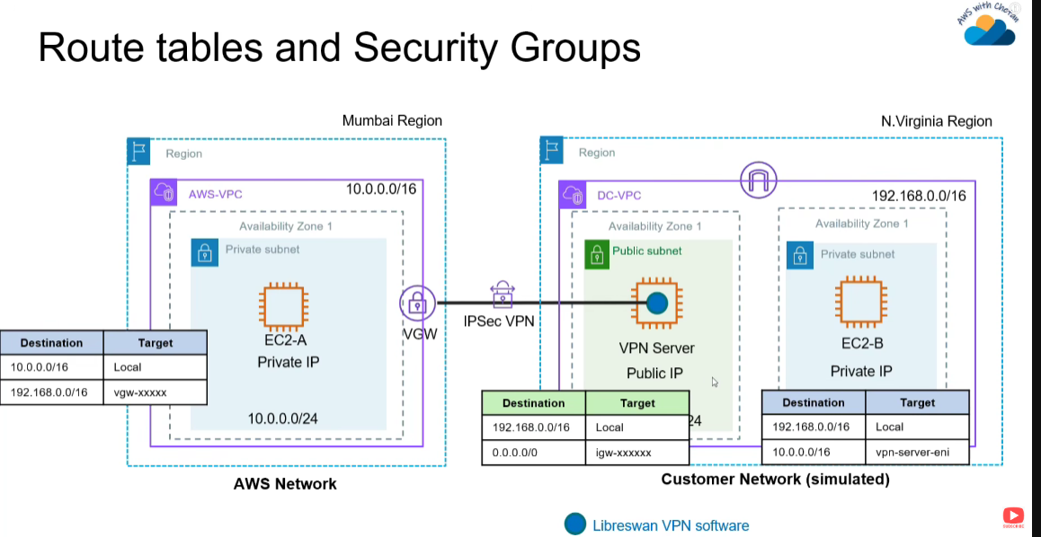

13.Go to DC EC2 instance VPN Server ->Action -> Networking -> Change Source/des check Select “Stop” ->Save
14. Go to DC-Private-RT -> Routes -> Edit Route->Add route->10.0.0.0/16(AWS network) target ->instance (VPN Server Public EC2 Instance)->Save changes
15. From Public DC EC2 instance VPN Server need to ssh to Private EC2 instance.so that we need add the key for that.
$ vi key.pem
<paste the key for DC Private EC2 key> and save the file
16.chmod 400 key.pem -> To change the permission for security
17.ssh -i key.pem <DC private IP of EC2 instance>
18.Ping <IP of AWS Private IP> 10.0.0.73 ->Ping will successful
End to End connection is working.

